# Univariate analyses

# Check for daylight saving shift! Ok!

# Bivariate analyses

Study the relation between **overall and specific place check-ins for:**

* check-in count
* time
* location
* accuracy

Time is analyzed based on the hour of the day, the day of the week and the week, yearly effects are researched as well.

# **Overall analysis**

## Analysis I: Check-in count versus time (univariate)

No obvious relation with hour and day of week. But related to the week!

**Train**

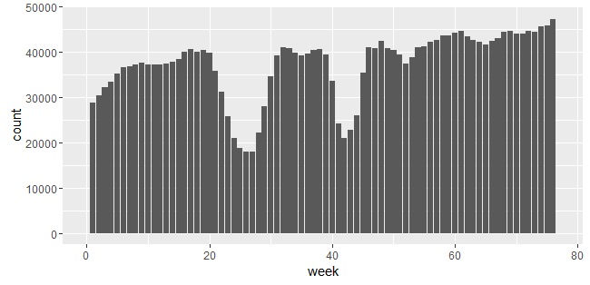

**Test**

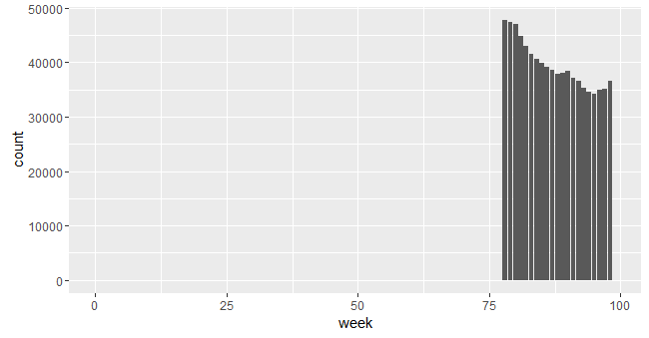

Maybe some places are more popular during popular times?

Add predictor that captures total week density (extrapolate last week) just in case!

## Analysis II: Check-in count versus location (univariate)

Total density in region and size of place

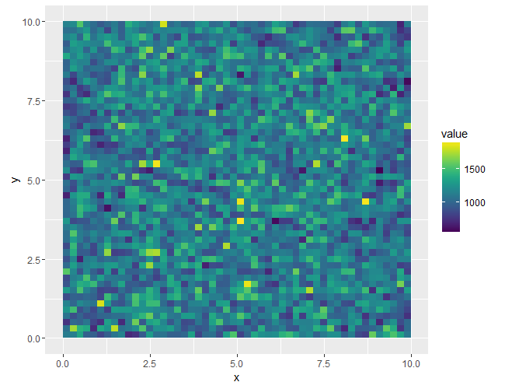Shows the observation count => no obvious pattern

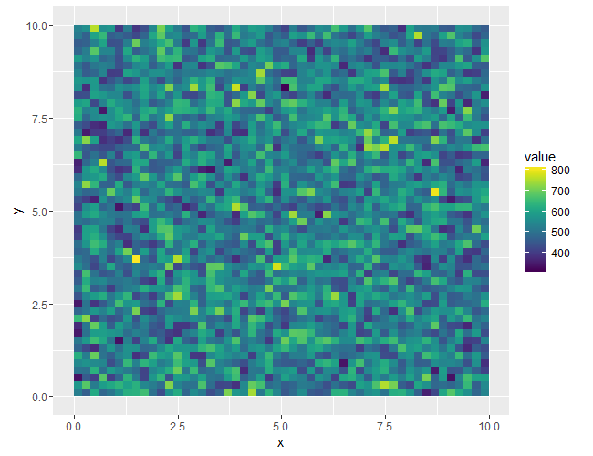

Shows the mean place count, no obvious pattern

## Analysis III: Check-in count versus accuracy (univariate)

**Train**

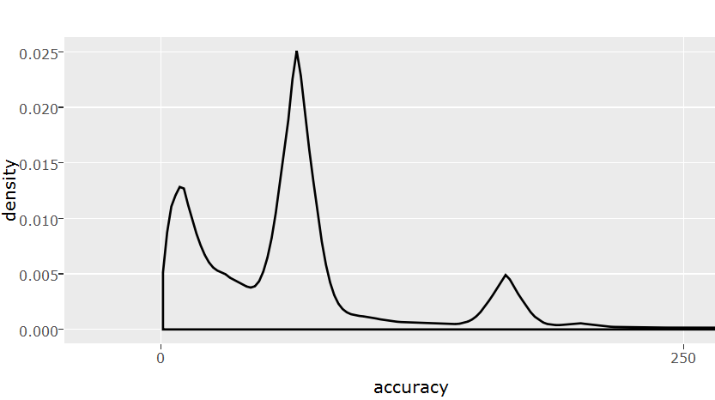

Interesting! Can these three peaks be explained??

**Test – No initial peak**

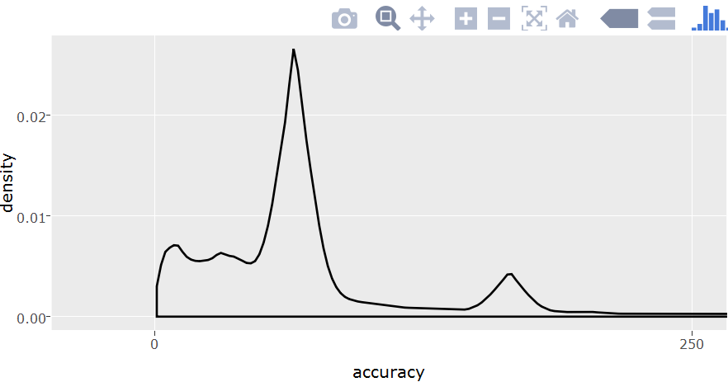

## Analysis IV: Week versus location

Weekly frequency visible, lower check-in rate at x and y edges but CRAZY time pattern – plot artefact or real? It was verified to be a plot artefact.

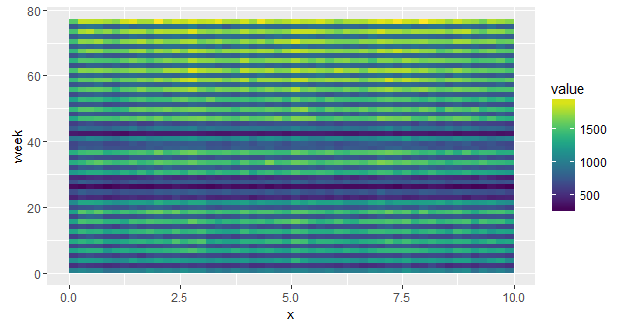

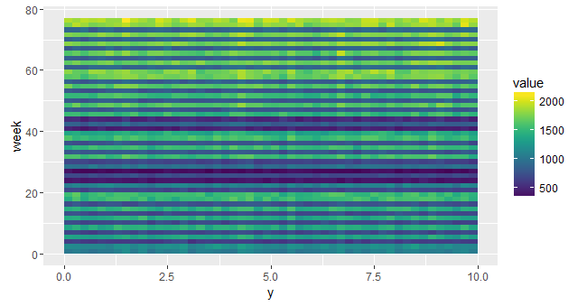

## Analysis V: Day of the week versus location

No obvious patterns

## Analysis VI: Hour of the day versus location

No obvious patterns

## Analysis VII: Week versus accuracy – sliding density

Week 1-4:

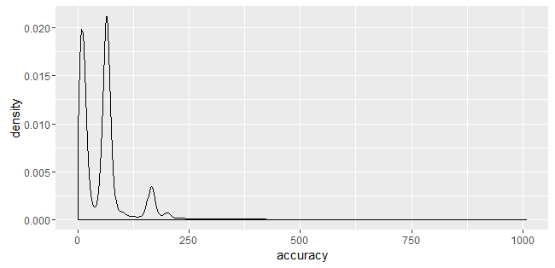

Week 72-76:

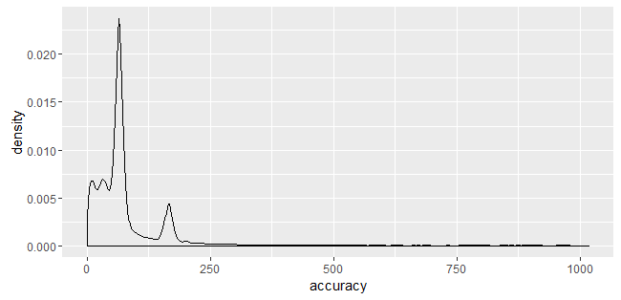

Calculate quantile feature of accuracy in week!

## Analysis VIII: Day of the week versus accuracy

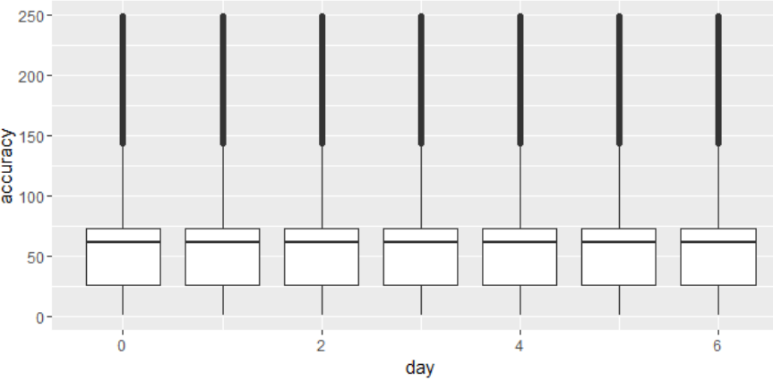

## Analysis IX: Hour of the day versus accuracy

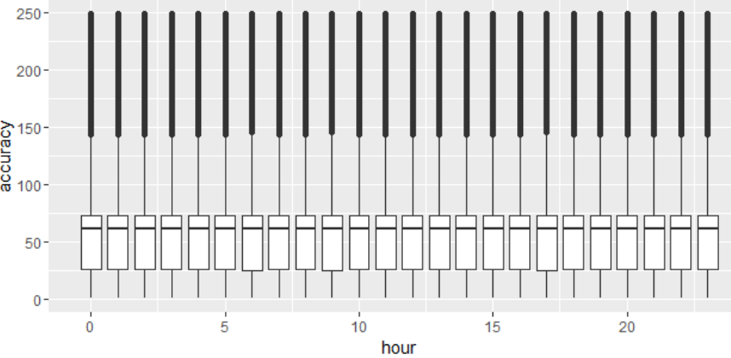

## Analysis X: Location versus accuracy

Median accuracy

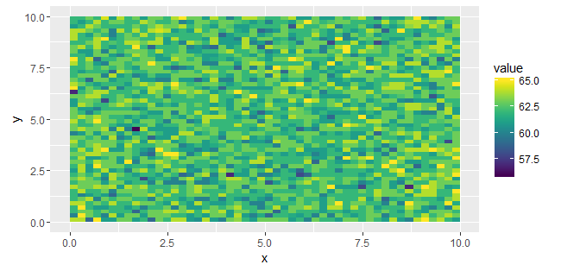

# **Specific place analysis**

## Analysis I: Check-in count versus time

### Year

No elevated density when looking a calendar year back in time

**BUT this one is interesting: looking at a +- 7 days window, days back, what fraction of the places did observe a checkin during that time frame**

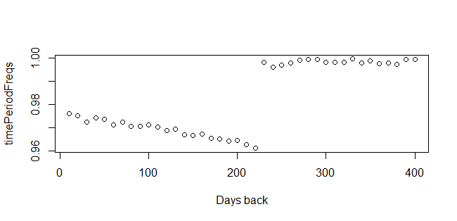

**Window of +- 1 day gives a more distorted picture:**

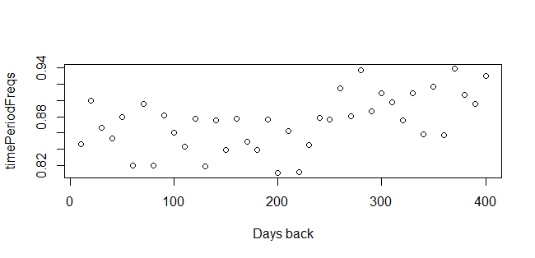

It seems like the historical activity (>225 days) is a better indicator than recent check-in events!!

Other interpretation: hardly any new places after 225 days?

Add time period density rescaled indicators of historical activity with focus on days back>225!

Maybe weekly density for each place id? => Matrix rather than vector

### Week

It’s very hard to identify patterns or even cluster of patterns => non parametric approach:

Time density corrected counts and relative time difference between new observations and KNN counts

### Day of week

Obvious pattern. Also include a feature that smooths the counts and a feature that uses the relaxed densities

### Hour of day

Obvious pattern. Also include a feature that smooths the counts and a feature that uses the relaxed densities

### X-minute period of day

Going beyond hour does not seem to make sense since the densities between the train and validation period do not align. Half hour plot:

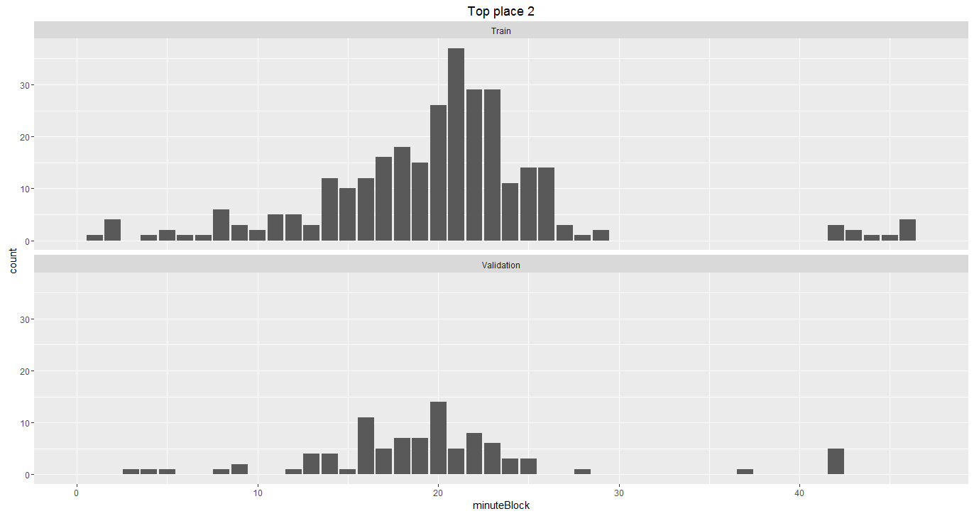

## Analysis II: Check-in count versus location

Same observation here as with the week trend analysis: it is very hard to derive general patterns. There are often strong outliers. Non parametric approach seems most reasonable here as well (multiple KNN counts). The robust Z score using med and mad are also likely relevant.

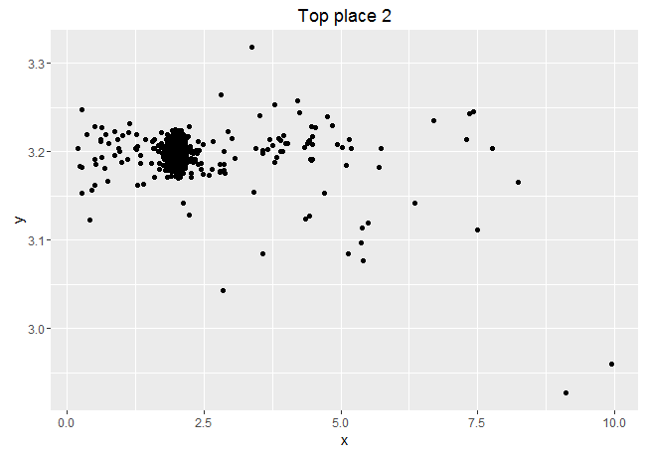 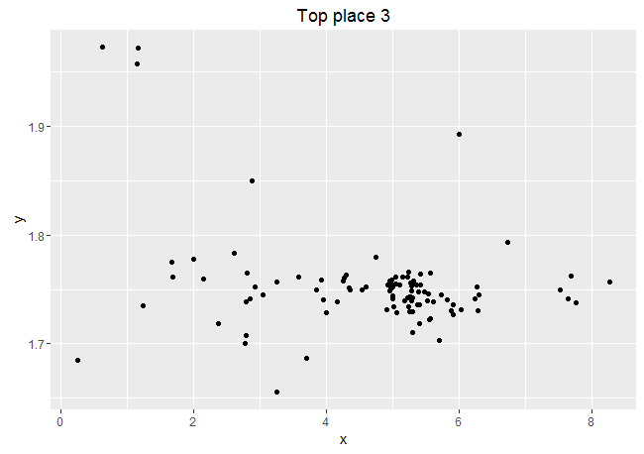

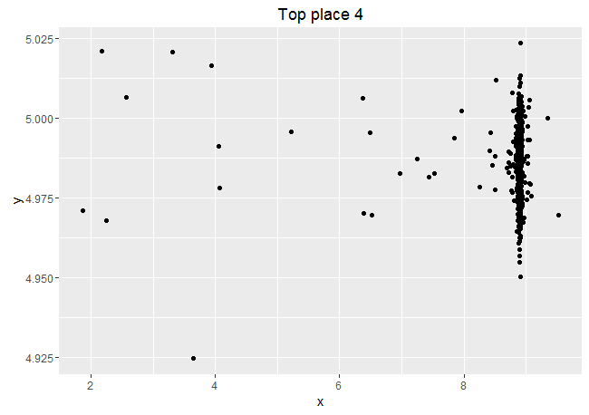 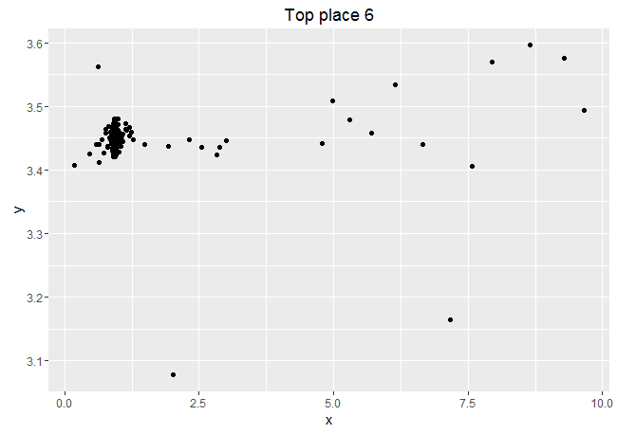

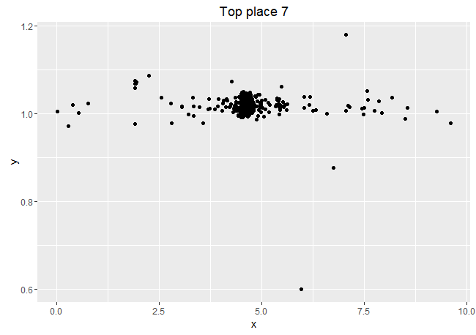 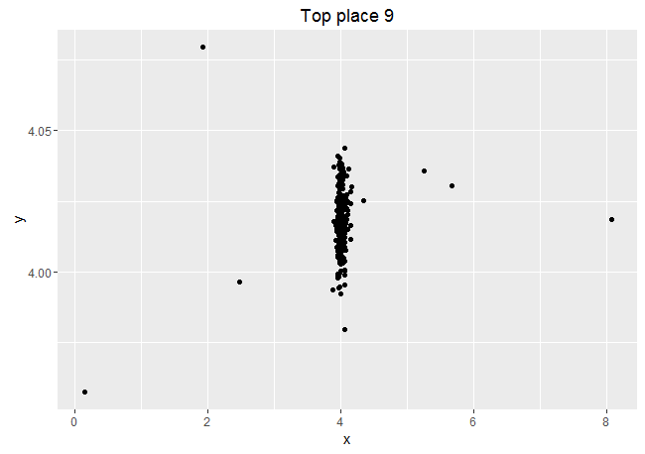

## Analysis III: Check-in count versus accuracy

All different densities, as suggested before: store quantiles for places?

## Analysis IV: Week versus location

No super obvious patterns but it seems like there is a slight relation between location and time

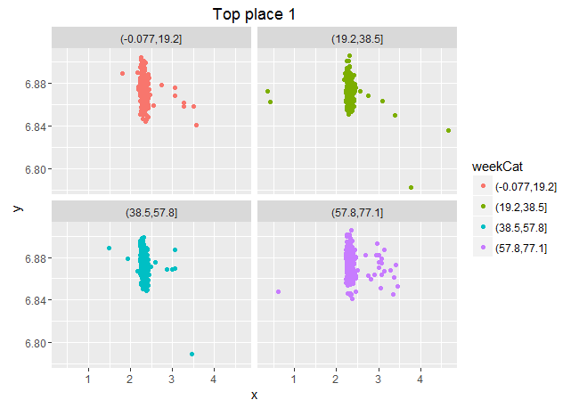

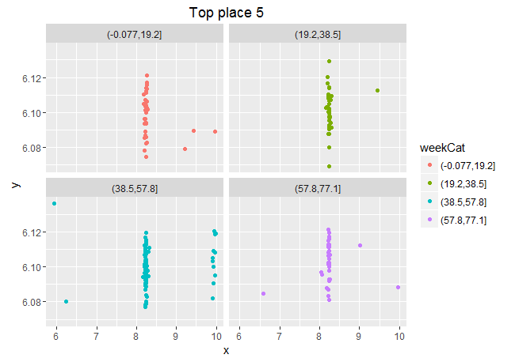

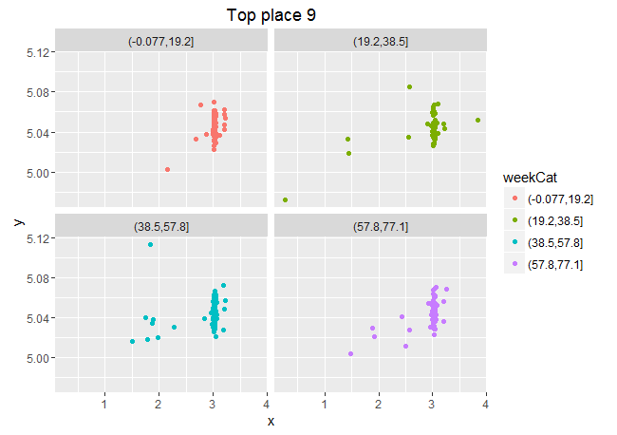

## Analysis V: Day of the week versus location

No obvious patterns

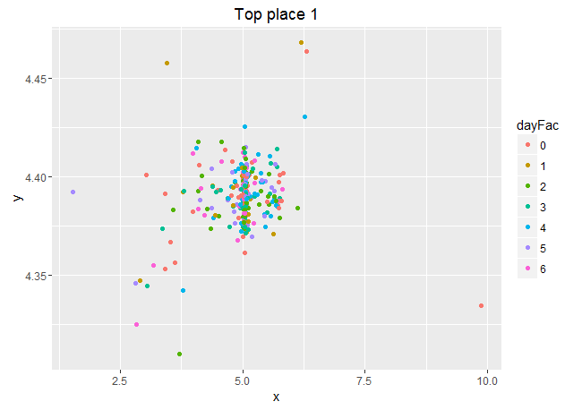

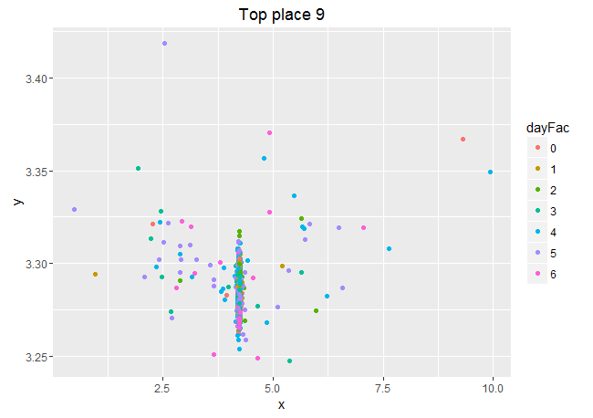

## Analysis VI: Hour of the day versus location

I tried hard to tell myself there is a pattern but in the end it’s not obvious ☹. It looked like there was a pattern since some hour ranges are more populated.

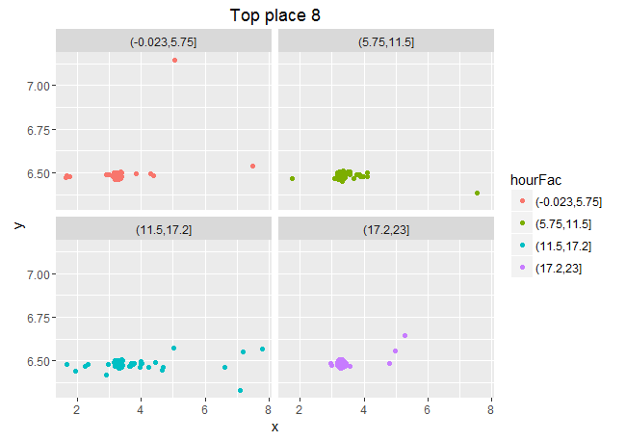

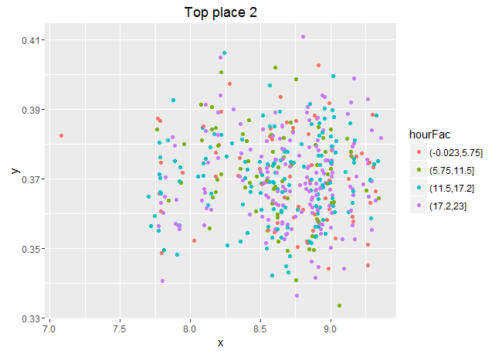

## Analysis VII: Week versus accuracy – sliding density

# Looking at the quantiles would be appropriate here (TODO)

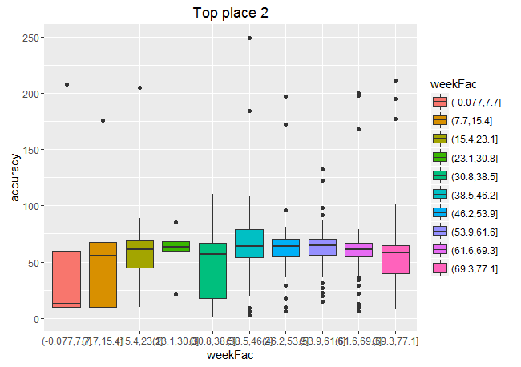

## Analysis VIII: Day of the week versus accuracy

Hard to find a clear relation

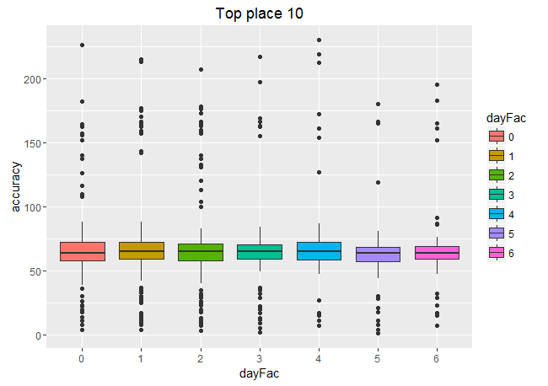

## Analysis IX: Hour of the day versus accuracy

No pattern either

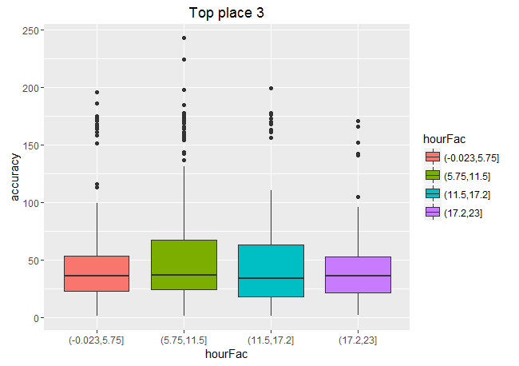

## Analysis X: Location versus accuracy

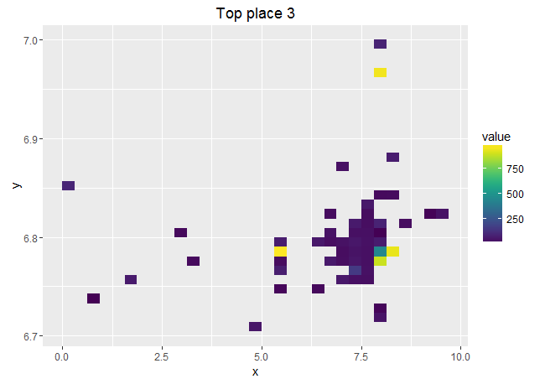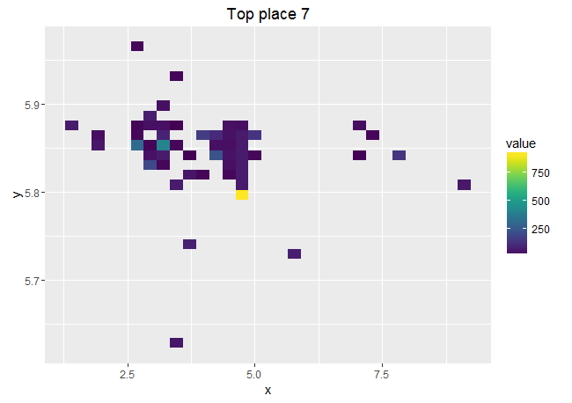

No clear pattern between accuracy and location

Interesting:

Hour seems to interact with day of week – 7*24 blocks! Smooth and relax!

